1.SUM OF DIGITS USING RECURRSION
Code:
import java.util.*;
public class Main {
public static void main(String[] args) {
Scanner s=new Scanner(System.in);
System.out.print("Enter num:");
int n=s.nextInt();
System.out.print(sumOfDigits(n));
}
static int sumOfDigits(int n){
if(n==0){
return 0;
}
return (n%10)+sumOfDigits(n/10);
}
}
Output:
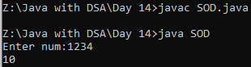
2.FACTORIAL USING RECURRSION
Code:
import java.util.*;
public class Factorial{
public static void main(String[] args) {
Scanner s=new Scanner(System.in);
System.out.print("Enter num:");
int n=s.nextInt();
System.out.print(fact(n));
}
static int fact(int n){
if(n==0 || n==1){
return 1;
}
return n*fact(n-1);
}
}
Output:
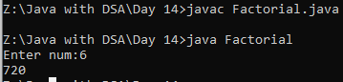
3.FIBONACI USING RECURSION
Code:
import java.util.*;
public class Fibonaci {
public static void main(String[] args) {
Scanner s=new Scanner(System.in);
System.out.print("Enter num:");
int n=s.nextInt();
System.out.print(Fib(n));
}
static int Fib(int n){
if(n<=1){
return n;
}
return Fib(n-1)+Fib(n-2);
}
}
Output:
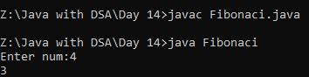
4.MERGE SORT
Code:
import java.util.*;
class merge{
public static void main(String[] args){
Scanner sc=new Scanner(System.in);
System.out.print("N:");
int n=sc.nextInt();
System.out.print("Array elements:");
int[] arr=new int[n];
for(int i=0;i<n;i++){
arr[i]=sc.nextInt();
}
int l=0;
int r=arr.length-1;
sort(arr,l,r);
for(int a : arr){
System.out.print(a + " ");
}
}
static void sort(int[] arr,int l,int r){
if(l>=r){
return;
}
int mid=(l+r)/2;
sort(arr,l,mid);
sort(arr,mid+1,r);
mergesort(arr,l,mid,r);
}
static void mergesort(int[] arr,int l,int mid,int r){
int left=l;
int right=mid+1;
int temp[]=new int[r-l+1];
int index=0;
while(left<=mid && right<=r){
if(arr[left]<=arr[right]){
temp[index++]=arr[left];
left++;
}
else{
temp[index++]=arr[right];
right++;
}
}
while(left<=mid){
temp[index++]=arr[left];
left++;
}
while(right<=r){
temp[index++]=arr[right];
right++;
}
int j=0;
for(int i=l;i<=r;i++){
arr[i]=temp[j++];
}}}
Output:
